A Limited Team Adventure
Anthony Alongi
You can access the first five installments of this occasional series on a new limited team's quest for Pro Tour glory in the archives here.
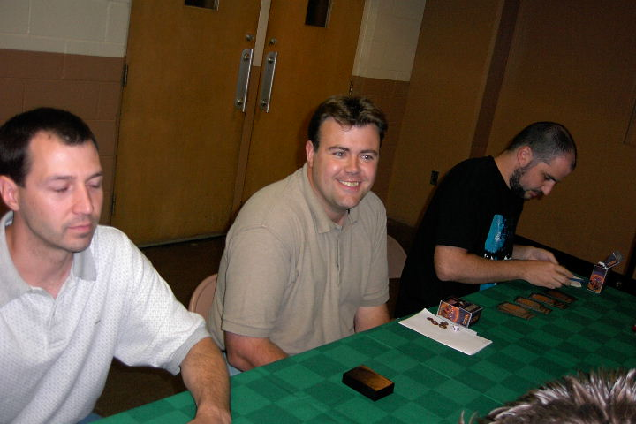
The team!
In this last part of the Limited Team Adventure series, I'll give you the scoop on how we did at the qualifier in Minneapolis for Pro Tour-New York, as well as the recent weekend at Columbus. In the final part, tomorrow, I'll tell you about the coolest draft I've ever played!
Bottom line for those given to executive summaries: we won't be playing in New York, but there's no doubt that our team did better with all of the hard work we put in, than we would have without it. And we're looking forward to next year.
Given the fact that it's the end of team season, I don't think including decklists will be helpful to people. I'll skim over basic deck details; and will be happy to send off full decklists to anyone who emails me with a request.

MINNEAPOLIS
In late June, we attended the qualifier put on by Steve Port and Legion. As always, Steve did a sound job with tournament organization. There were over forty teams present. With 120 individuals, this ranked a bit higher in attendance than most individual PTQs, which hit about 100 or so in our area. We received one sealed deck for the day - eight rounds - and it was the deck we registered. We were not thrilled, but not depressed either. More like, bemused.
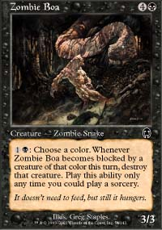
In all of our practice sets, we had never seen one where the black-red looked so tired, especially in creature quality. Two Duskwalkers and Zombie Boa were my fifth turn "bombs"; virtually everything else was one toughness, e.g. Rogue Kavu. We had also never seen one where the blue-red axis was so strong - and a Lightning Angel was there, to boot. Todd built his deck white-blue-red, which was absolutely right but did swing a couple of cards away from me. To make up for it, I got some blue-black discard power (two Cavern Harpies to go with two Ravenous Rats, and a Probe). Bob, as usual, got the green deck; in late testing we had figured he stood a chance with red removal, so the Ghitu Fire went from my deck to his.
Yes, we spread red across three decks. This was probably a mistake; but the card pool really threw us for a loop. And that Dwarven Patrol looked positively stellar in Todd's blue-white deck. ("After you announce attackers, Pollen Remedy on my Patrol, untap the Patrol, block...")
We started off nicely enough, facing a team called PC Load Letter patched together from some Dreamers regulars, including Dale Taylor, one of the top players in the state and whose Team Monster Rod placed Top 8 at PT-NY last year. I was paired against Dale, which amazingly made for the first sanctioned match between the two of us, despite us being in the same room at various Dreamers tournaments over the past year. Dale is incredibly fun to play Magic with, and is an excellent example of how a sense of play and serious skills can combine in a tournament competitor.
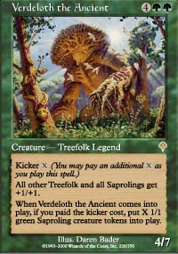
It's never good when this guy shows up on the other side of the table.
Dale had the junk green deck; I think I recall seeing a Verdeloth and a Legacy Weapon somewhere in his deck. But this is red-black's best match up, and my deck gave me a good show for two games. Reckless Spite kept my momentum going for both games, and I was pleased to see my Duskwalkers and Zombie Boas show up - because those were all I had! Todd Hobbled and Confounded (he had two of each) his opposition into his own match win, and the fact that Bob met up with a Hunting Drake a few too many times was moot.
In round two, I ironically had my most enjoyable match of the day, against "Mike" from Team Phat Kids. This was essentially a mirror match; but my deck showed its true discard colors in this match up. We traded blowouts in games one and two, and then turned game three into a real barnburner. What made the difference in this matchup was the presence of a late game - Mike had one, in the form of multiple good removal cards; I had none, being dependent on discard and weenies. At the end, as we traded blows below ten life, he was swinging for three while I was swinging for one and two. R-B-u can't win like that. In the other two matches, both blue-white mages beat both green-x mages... is there really anything to learn from that? And so we went into the third round at 1-1.
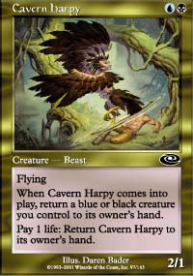
In round three, we played against The Good, the Bad, and the Lucky. This was a team of solid, younger players who ended up third on the day. I fear their tiebreakers, which would have included us in that calculation, may have made the difference between third place and a spot in the Top 2. My opponent, John, had the green-x deck... but this green-x deck reminded me more of the deck I mentioned in this space a few weeks ago, with a great red-white axis. He was able to rush me quickly in two games, putting my discard deck in the control position and using Squee's Embrace to make his favored creatures stronger than anything else I had. My Cavern Harpies fought valiantly in game two; and I had him down to 3 life... but again, a red-black-blue deck has to be able to finish. Mine couldn't.
The next four rounds were a horrible blur of white-blue opponents, every single one of them playing one or both Acolytes and a color shifter (Tidal Visionary or Blind Seer... one guy had both). Wait... one of those decks wasn't blue-white; it was red-black mirror with Darigaaz. (My Cavern Harpies were really tired after that match-up!)
In any event, after seven rounds, we were 4-3, with Todd's white-blue-red winning consistently and Bob and I offering little, if any, help. I was, by now, firmly down on discard as a viable Limited strategy... at least in a beatdown deck. (Yes, that's irony you hear.)

Adrian [Sullivan] is an excellent reminder of why people play this game - for the fun of it.
And then in the eighth round, I got matched up with Adrian Sullivan (Team Ya Got Us), which just made the whole day worthwhile. I had been glad to see Adrian make it to the event, and before registration he had shown me one or two new casual play formats. Adrian is an excellent reminder of why people play this game - for the fun of it.
In game one, Rogue Kavu and Zombie Boa brought the smackdown, and a late-game Thunderscape Battlemage seemed to take the wind out of his sails. In game two, he played out both Acolytes (did I mention he was blue-white?) and never saw less than eighteen life.

Our fearless leader Todd suddenly went cold...
In the critical game three, I made what I would call my one key play mistake of the day: with Adrian at 13 life, momentum shifting from him to me, and both a Zombie Boa and Duskwalker on the board, I swung, got through for three (10), and then played out a Cavern Harpy, which required bringing one of my beasts back to my hand with not enough to recast. This was an error; I was doing just fine with what I had. Adrian showed a red splash then - Raka Sanctuary - and while he could only do one point to a creature initially, that was enough to send the Cavern Harpy packing and render my last turn's play totally useless. Three turns later, he had a blue permanent join the white one, laid out a Crimson Acolyte...and I could only get him to 4 before losing all my creatures and the match. If I keep both 3/3s on the board (a condition that was rare enough for the day that I ought to have enjoyed it!), I swing for another guaranteed three the following turn (7), then another three the next turn (and this is with him losing blue and white creatures to the Boa), and then with him at four, no creatures, and a useless Sanctuary, I at least get to write the story differently. (Which I guess I just did. Too bad I didn't get to write it on the match slip.) You cannot play opponents of Adrian's caliber and expect to get away with nonsense like this.
My game, again, was the pivotal one. Bob's valiant win with his green-x deck was wasted, as our fearless leader Todd suddenly went cold and succumbed to a five-color rush deck. We ended the day at 4-4. (We kept going after 3-2, for those of you who want to know where we were at the "drop" mark.) Individually, I was 2-6: my worst record since the Nemesis Prerelease, when I started with Limited formats. After finishes like 4-1 and 5-2 at strong player locales like Dreamers, this felt less than completely good.
But whining doesn't help you learn. The good things our team brought from this experience? Well, first off, we really got a sense of the mortality of the field. No team at the qualifier exhibited such strong play or deckbuilding skills that we felt overwhelmed. We'd feel perfectly comfortable in that level of competition again, no question. So the practice absolutely helped our confidence, even if our match record didn't. The team that qualified that day is a solid team; they are also a local Dreamers team whom we have beat before. I'll be rooting for them loudly; they're terrific younger players with a nice, quiet, professional style. And with three solid decks and three solid players who knew how to build and play them, they deserved to win the day.
Second, we got a lesson in the unpredictability of Team Sealed - not even months of practice, with several tournaments against key local teams, can help you if your cards are questionable, and your build spreads one color (red) over three decks.
Third, we got some practice in pointing the fingers at ourselves - despite all that practice, play errors like the one I made against Adrian could easily have made the difference between 4-4 and 6-2.

JULY - HIBERNATION
The practice pace we had kept during May and June was impossible to maintain. Family vacations sucked away at least two weeks in July, and what you college kids may hear about workplaces in summer is, frankly, untrue. Between extra hours worked, valuable time spent with family and the like, practices were far less frequent: about four, throughout the entire month.
So if any of you want to link that to the performance below, feel free. But honestly, I think after practicing multiple times each week for a few months across 12-15 card pools, as well as several local sanctioned and non-sanctioned tournaments, you've learned what you're going to learn, at least until you can hit locales like Columbus and play against some of the best players in the game.
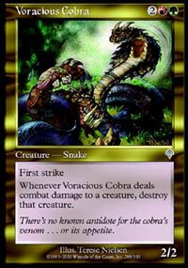
We did, during July practice, duplicate the card pool of the team that qualified in New York (thanks to the Your Move Games website), but didn't look at their final build until we had done our own. We were more generous with the green deck than they were (most of the red removal stayed with red-black), and we ran Voracious Cobra where they didn't (?), and we splashed green (Mystic Snake) into the blue-white where they didn't. So there are differences there, and we felt we should try to learn from that. We tried to contact them to find out why they made the decisions they made; but couldn't reach them. One thing we did notice about the decks they built: the red-black and blue-white were relentlessly two-color, with no splashes. While our occasional R-B-u and B-W-g builds don't typically run into color screw - I don't think we lost any matches in Minneapolis because of mana color - we can accept that a more consistent build in those two decks would also give the green deck a few more tools to play with.

COLUMBUS
A quick word on the logistics in Columbus: we were not impressed. We had heard excellent things about Professional Events Services; but the Trial and Grand Prix took much longer than we expected to start. The event itself went smoothly once started; PES does have a solid reputation there.

My own deck was incredibly strong.
A word to the convention community of Columbus: we need food. "Will pay for food." Closing facilities at 3pm, for a building in a neighborhood with a single restaurant (two blocks away), is less than stellar business sense.
We arrived in time to participate in the Trial for Columbus; we felt that it would be good to warm up a bit for the big event, and with luck get a bye or two.
As with the PTQ in Minneapolis, we got our own decks back. This time, we were not amused; we were outright annoyed. This was the first card pool we had ever seen where white-blue was a complete loss: three flyers total, with Faerie Squadron on the high end; and nothing to hold the ground beyond a Prison Barricade. Green-x was its usual basket case - with four of the Apocalypse bears and a Coalition Victory, we briefly toyed with having a bit of fun at our own expense - but in the end, we went with a more conventional build. Green-red-black was the base.
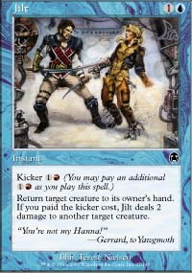
My own deck was incredibly strong. Red-black was very good to me, and there were also two Jilts and Prophetic Bolt for an easy splash. We thought for a moment of putting this red-splash into Todd's blue-white deck; but that would have split red over three decks again, like we did at the qualifier. And we weren't going to learn much with that approach. In addition, this was Todd's first time with a sub-par deck; and we were interested in seeing if our best player could make do with low-end tools. Trials are somewhat low-stakes events; and with this card pool, we felt we would get more out of a questionable, test-driven build than a more conventional, equal-decks build.
Despite Todd's best efforts, the evening went as we feared. I lost one match to a Rout-based deck and cruised in my other three matches; Bob came out with a 2-2 and Todd an unusually depressing 1-3. With our team at 2-2, feeling a bit tired from the flight and continual play, and having learnt all we needed to learn, we saw no reason to continue. We went to the Spaghetti Warehouse, a great little specialty restaurant just northwest of the Franklin Center where the Grand Prix was held. (Since Columbus gets its share of high-profile events, I recommend locating that restaurant if you're ever there, especially given their Magic player friendly closing time of 11:00 PM! But do tip well if you're going to stroll in around 10:58 and have to pass by seven tired staff members as you leave at midnight.) Todd and Bob went 4-0 against a pitcher of beer, while I topdecked some pre-linguine applesauce. Best since Mom's.
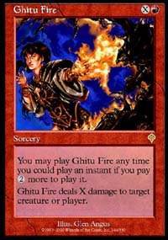
At the Grand Prix itself, we got our first card pool that we felt was solid, through and through. My deck had Skizzik, Pouncing Kavu, Ghitu Fire, Agonizing Demise... all of the tools that I was used to from the practice pools. It flourished a bit later than a normal beats deck; but as it turned out that wasn't too much of an issue. Todd's deck had an armada of flyers and good control cards like Hobble and tappers. Even Bob's green deck had a nice, smooth curve with two Nomadic Elves, Noble Panther, Ancient Spider, Stone Kavu, and Serpentine Kavu...along with two Armadillo Cloaks.
After we register our decks, I go up to Randy Buehler and say, "if we lose, it isn't our decks. Corner me on that. Don't let me say anything else."
We figured 2-1 would be easy. 3-0 was possible.
We went 1-2.
What can I say? I know what I can't say: it wasn't our decks. Randy would keep me honest, there.
Round one was a feature match; you can find the link in Grand Prix Columbus coverage. We played against Six Degrees of Kevin Bacon, which featured some solid players with high-placing Grand Prix history. This was, in short, the venue where we wanted to show our stuff.
We played solidly, but were overwhelmed by superior players and yes, even superior cards. At one point, I looked at the board. I was facing down Tahngarth and a Pouncing Kavu; Todd was facing down Rith, some saproling tokens, and some bird tokens off a fourth-turn Ordered Migration for four (this happened twice); and Bob was facing a Sunscape Master and two tappers. "Welcome to the Grand Prix, team! Here are your butts."
I honestly feel I could have pulled out my individual match - my deck was just as loaded with bombs as my opponent's. Smoldering Tar, Skizzik, and Breath of Darigaaz are only three of seven cards that could have killed or neutralized Tahngarth. But my opponent paced himself beautifully, and I got my answers too late to be of any help. Sometimes, bomb-decks lose. As I said before... you can't blame the deck!
Round two was more to my liking, if not my teammates'. Doing an amazing simulation of my first-round opponent when he played against me, I ripped through a 5-color deck twice in less than five minutes. (After the match, he suggested he shouldn't have kept his hand in the first game: six lands, including the four colors of his deck, and a Power Armor. I agree, at least until he sees what he's playing against. A good red-black is just unforgiving of that sort of start.) Todd, meanwhile, lost a protracted battle to a B-U-r control deck splashing for Goblin Trenches; while Bob admitted a misplay of his Diversionary Tactics against a red-black rush deck, which cost him game one and possibly the match. Facing down a Shivan Zombie and Crypt Angel when you have Diversionary Tactics is, you might say, a good metagame call for the opponent.
In the 0-2 bracket, we did feel like our decks ought to pick up a match win. And we did. Bob lost to another black-red rush deck; but Todd won a conventional through-the-air matchup against a groundpounding deck. I faced the most intriguing opponent: "Steve", with a blue-black-green deck featuring Mystic Snake, Consume Strength, and Recover. This was the match where I felt good card pool, good deckbuilding, and good play culminated for me personally, so I'll spend a few paragraphs basking in the glory of it all.
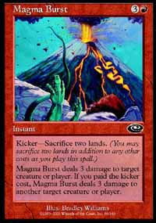
In game one, I found myself on the receiving end of early beats, and was below 10 life before I stabilized with a Phyrexian Gargantuan and Magma Burst. As Steve's hand ran out of cards, I built up enough mana to cast the one impractical card in my deck: Bloodfire Colossus. Sitting at eight life, I wheedled him down to five, picked up my ninth land, and then let the big-red-exploding boy do the rest of the talking.
In game two, as I struggled to find my fourth land, he whittled me down to six. Now the Colossus was no longer a solution... but the Breath of Darigaaz in my hand was. I aimed for an "honest draw" in this game, since that will pin my opponent to no better than a match draw against me. I hold off attackers with 3/3s as I get my desperately needed fourth and fifth mana; then I punch through with a Pouncing Kavu enough times to get him to four as I sink down to three from a flyer. As I see no way to remove the flyer - and a Consume Strength will beat me next turn - I play the Breath and we go to game three. (Incidentally, no stalling was involved. We finished our match with five minutes to spare.)
In game three, my deck suddenly realized it had early plays like Rogue and Hooded Kavu. It played out like a machine, and before long he's at seven life and facing down a couple of beasts on my end. He found a Sea Snidd to threaten a trade; it was the last card in his hand.
Out of the four options I had in my own hand, I play out Smoldering Tar. This next comment is why I remember Scott's name:
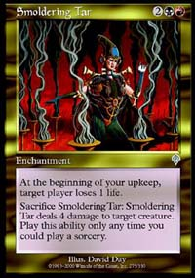
"Smoldering Tar? Why, that's Tar-tastic!"
After swinging across a clear board, in rather anticlimactic fashion, I used Breath again... this time, to win the match 2-0-1. Steve was a terrific opponent, with a great sense of humor and sportsmanship. I hope, even in my less spectacular moments later on that day, that I was as gracious as he was. (But I doubt it.)
Since 5-2 had a shot at making Day 2, we stayed in and hope to get as good a card pool as we did the first time.
We did not.
I hope my readers enjoyed my own individual winning streak, there. (I was 5-2 individually, across a group record of 3-4. Usually, I'm more the pace-setter, not the overperformer.) It went south from there. We opened a card pool similar to the one from the trial, except worse in that it had no good, single-deck build. All three decks were mediocre; mine was horrific. My creatures were awful; among my best were two Slinking Serpents, since I needed to splash blue to get to 23 good cards. There was an Undermine in our card pool; but no deck found a main deck home for it - I didn't have enough early blue, Todd didn't have the tools to splash black, and it was too far gone for Bob's deck. With a bit more imagination and a little more patience for yet another card pool that looked nothing like what we had practiced with, we might have built better.
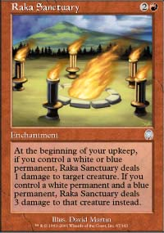
Instead of black, Todd's deck splashed red because of Raka Sanctuary and Jilt. It's possible Jilt could have gone in my deck; but I needed better creatures, not better removal.
Bob's deck was a decent green-x deck, which is about as good as a bad red-black deck.
Gentlemen, start your engines!
I'll tell you what I remember from the next two matches. I remember losing in three games to a twelve-year-old playing a sixty-card, five-color deck. (Todd and Bob won, thank goodness, against similar decks.) And I remember losing in three games to a red-black mirror where a game three fifth land, in any of my last three draws, would have let me cast Planar Despair to reset the board completely.

Planet of the Apes could have ended a lot better, don't you think?
And then I remember taking a taxi to see Planet of the Apes, which involved yet another dramatic twist I couldn't completely stomach.
Folks, if ever you doubted my ability to play in Limited formats, doubt no longer. I took my deck in both of those matchups to three games, and that's all the authority I need.
I was too bitter after the fifth round to ask my teammates how their matchups developed. This, everyone, is called poor sportsmanship. It reflects badly on the player, especially in a team sport. And rather than cover for this article and ask Todd and Bob retroactively about their matchups so I can fill in detail and look good, I think would rather allow my readers to think a bit less of me, since my behavior at that point in time warrants it. I was not a pretty sight, and I apologize to my teammates and my opponents for any bad vibe that came off of me.
But really, Planet of the Apes could have ended a lot better, don't you think? That's the ticket. I would have top-decked that fifth land; but Tim Burton screwed up the ending.
On to a rather intriguing experience for Day 2: The Pro Tour-New Orleans qualifier. This was the second sanctioned Constructed event I have ever played; and our team prepared very lightly for this. Yes, people, we used net decks! And we loved it. What a great tool for time-pressed parents who want to play Constructed Magic! I highly recommend it. Of course, you'll have a harder time winning with a deck that is not your own; but you'll do well enough to have a good time.
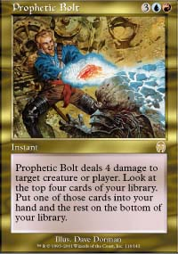
Actually, Todd found a last-minute, more original creation by Scott Seville of Team Grape Apes. This was a G-U-r with Bobcats and Prophetic Bolts as a path to victory. I've heard tell from other players of similar decks since this event; but I don't think many players were running this in Columbus. So Todd was our designated anti-net deck representative for the day.
This is a team Limited series, not IBC, so I'll stay brief: I ran a conventional blue-green tempo deck (four each of Gaea's Skyfolk, Blurred Mongoose, Kavu Titan, Mystic Snake, Repulse, Exclude, Rushing River, Fact or Fiction, and Temporal Spring), with a pretty conventional sideboard (Gainsay, etc.), but with one change: I took out the Dodecapods, since I figured black discard was already scared away from the field, and put in my special 2x Tangle tech for use against red-green, and possibly the mirror matchup. Laugh if you will, but my experience in the actual event proved that...well, I never drew them, so it proved that two of a sideboard card probably isn't enough.
Since we only had four Mongooses among the three of us, Bob was kind enough to run four Barbarians main deck instead of the untargetable little rodents, and feels he suffered for it. Thanks for taking yet another one for the team, Bob. You're "Tar-tastic!"
Like I said, a brief summary:
- I lost first match against a red-green deck. In retrospect, I should have mulliganed my third hand (which had only two lands and wrong color configuration). May not have won; but it would have stopped the first two Yavimaya Barbarians.
- I won the second match against a rogue g-w-b, Necra Sanctuary deck. Rushing River is fantastic in IBC; I was not a believer until I put both a Fleetfoot Panther and Necra Sanctuary back in my opponent's hand and swung for six.
- I won the third match against a domain deck that was using a less-than-conventional build with Legacy Weapon and Cromat. (Blurred Mongooses are good against the Weapon; Gainsay was predictably good against his entire deck.) From what I saw in other matches, I don't think even more conventional domain builds are competitive in IBC, yet. Perhaps that will change.
- I lost the fourth match to Jamie Parke, a seasoned player with a G-B-w deck to control until Phelddagrif drops. This match was a blur of Fact or Fictions on both sides; in the end, of course, he was the better player. I also like the splash of white; Absorbs and Sunscape Familiars allow for the controller to win counter wars that they otherwise wouldn't have the time or mana to win.
Neither Todd nor Bob ran really hard in this event; we all knew that we had a flight that evening. We were playing for the delight of it all, and it was great. I even caught an extraordinarily sportsmanlike moment from Todd, where his match was grinding down toward time in a third game. Time was indeed called, and on the fourth turn afterward, Todd checked in with a judge, and then conceded his match to a very strong opponent who Todd felt deserved a match win, instead of a draw. It was a good reminder of why I get along with guys like Todd.
And that's my little primer on Invasion Block Constructed. (Do I smell a new Sideboard series?)
I've saved the best story of the weekend for last, and tomorrow you can read all about the most amazing draft I've ever played.
Check out this table:
1. Gary Wise
2. Zvi Moshowitz
3. Brian Kibler
4. Patrick Mello
5. Phil Freneau
6. Scott Johns
7. Kai Budde
8. Anthony Alongi
See you tomorrow!

